Candidate Name:- ROHITHGOWDA V

Superset ID:-6430364

Mail ID:- [rohith2005v@gmail.com](mailto:rohith2005v@gmail.com)

**WEEK – 7 HANDS ON EXERCISE (JAVA FSE DEEPSKILLING)**

**REACT**

**Problem no:1**

Create a React Application named “cricketapp” with the following components:

1. ListofPlayers

* Declare an array with 11 players and store details of their names and scores using the map feature of ES6

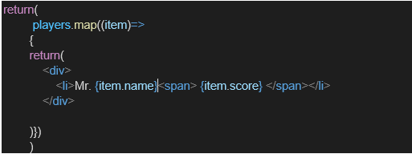

* Filter the players with scores below 70 using arrow functions of ES6.

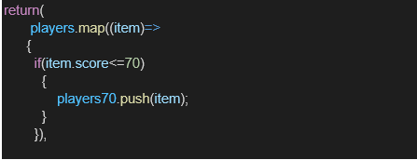

1. IndianPlayers
   1. Display the Odd Team Player and Even Team players using the Destructuring features of ES6

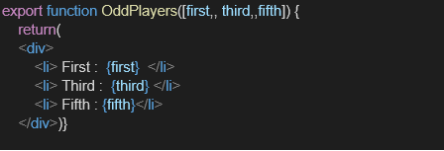

* 1. Declare two arrays T20players and RanjiTrophy players and merge the two arrays and display them using the Merge feature of ES6

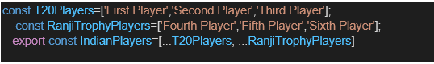

Display these two components in the same home page using a simple if else in the flag variable.

**Output:**

When Flag=true

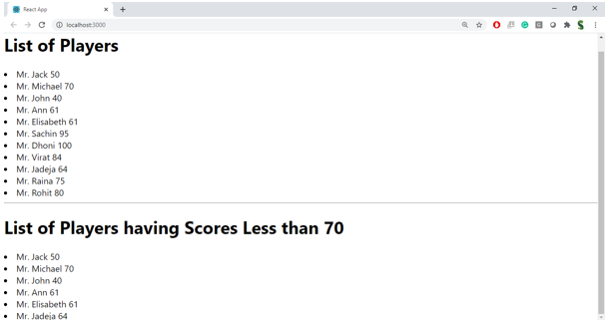

When Flag=false

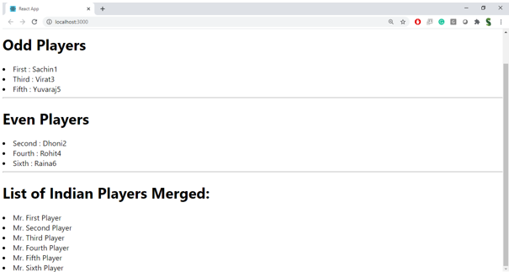

**Solution:**

**EvenPlayers.js**

import React from 'react';

function EvenPlayers({ IndianTeam }) {

  const even = IndianTeam.filter((_, index) => index % 2 !== 0);

  return (

    <ul>

      {even.map((player, index) => (

        <li key={index}>

          {["Second", "Fourth", "Sixth"][index]} : {player}

        </li>

      ))}

    </ul>

  );

}

export default EvenPlayers;

**ListofindianPlayers.js**

import React from 'react';

function ListofIndianPlayers({ IndianPlayers }) {

  return (

    <ul>

      {IndianPlayers.map((player, index) => (

        <li key={index}>{player}</li>

      ))}

    </ul>

  );

}

export default ListofIndianPlayers;

**ListofPlayers.js**

import React from 'react';

function ListofPlayers({ players }) {

  return (

    <ul>

      {players.map((player, index) => (

        <li key={index}>{player.name} {player.score}</li>

      ))}

    </ul>

  );

}

export default ListofPlayers;

**OddPlayers.js**

import React from 'react';

function OddPlayers({ IndianTeam }) {

  const odd = IndianTeam.filter((_, index) => index % 2 === 0);

  return (

    <ul>

      {odd.map((player, index) => (

        <li key={index}>

          {["First", "Third", "Fifth"][index]} : {player}

        </li>

      ))}

    </ul>

  );

}

export default OddPlayers;

**Scorebelow70.js**

import React from 'react';

function Scorebelow70({ players }) {

  const filtered = players.filter(player => player.score < 70);

  return (

    <ul>

      {filtered.map((player, index) => (

        <li key={index}>{player.name} {player.score}</li>

      ))}

    </ul>

  );

}

export default Scorebelow70;

**App.js**

import React from 'react';

import './App.css';

import ListofPlayers from './Components/ListofPlayers';

import Scorebelow70 from './Components/Scorebelow70';

import OddPlayers from './Components/OddPlayers';

import EvenPlayers from './Components/EvenPlayers';

import ListofIndianPlayers from './Components/Listofindianplayers';

function App() {

  const flag = true;

  const players = [

    { name: "Mr. Jack", score: 50 },

    { name: "Mr. Michael", score: 70 },

    { name: "Mr. John", score: 40 },

    { name: "Mr. Ann", score: 61 },

    { name: "Mr. Elisabeth", score: 61 },

    { name: "Mr. Sachin", score: 95 },

    { name: "Mr. Dhoni", score: 100 },

    { name: "Mr. Virat", score: 84 },

    { name: "Mr. Jadeja", score: 64 },

    { name: "Mr. Raina", score: 75 },

    { name: "Mr. Rohit", score: 80 }

  ];

  const IndianTeam = ["Sachin1", "Dhoni2", "Virat3", "Rohit4", "Yuvaraj5", "Raina6"];

  const T20players = ["Mr. First Player", "Mr. Second Player", "Mr. Third Player"];

  const RanjiTrophyplayers = ["Mr. Fourth Player", "Mr. Fifth Player", "Mr. Sixth Player"];

  const IndianPlayers = [...T20players, ...RanjiTrophyplayers]; // ES6 merge

  if (flag === true) {

    return (

      <div>

        <h1>List of Players</h1>

        <ListofPlayers players={players} />

        <hr />

        <h1>List of Players having Scores Less than 70</h1>

        <Scorebelow70 players={players} />

      </div>

    );

  } else {

    return (

      <div>

        <div>

          <h1>Indian Team</h1>

          <h1>Odd Players</h1>

          <OddPlayers IndianTeam={IndianTeam} />

          <hr />

          <h1>Even Players</h1>

          <EvenPlayers IndianTeam={IndianTeam} />

        </div>

        <hr />

        <div>

          <h1>List of Indian Players Merged:</h1>

          <ListofIndianPlayers IndianPlayers={IndianPlayers} />

        </div>

      </div>

    );

  }

}

export default App;

**Output Images**

flag=false

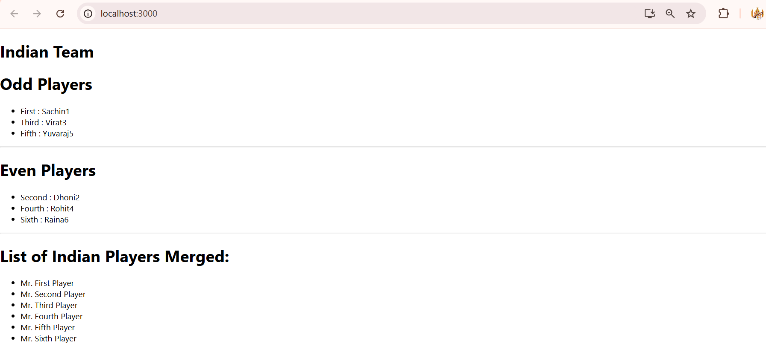

flag=true

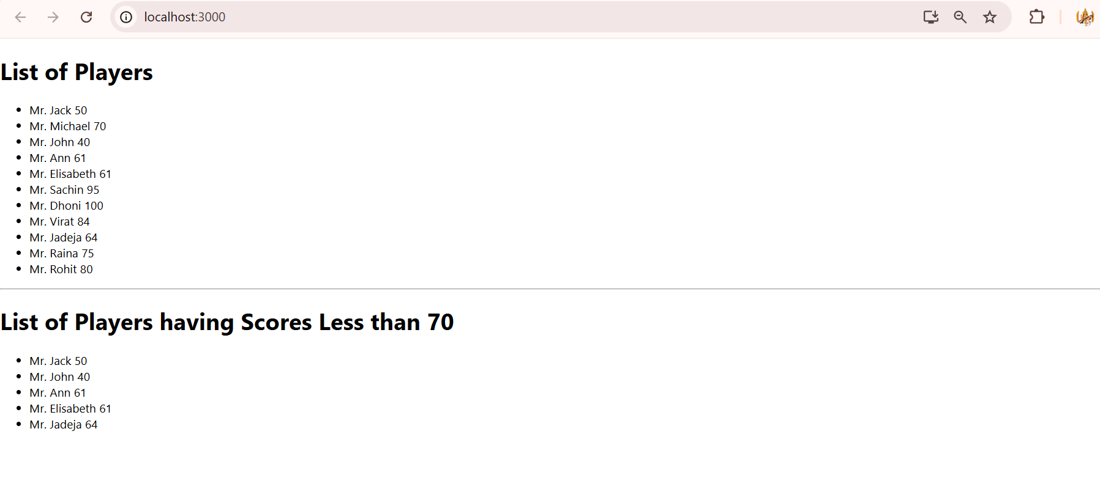

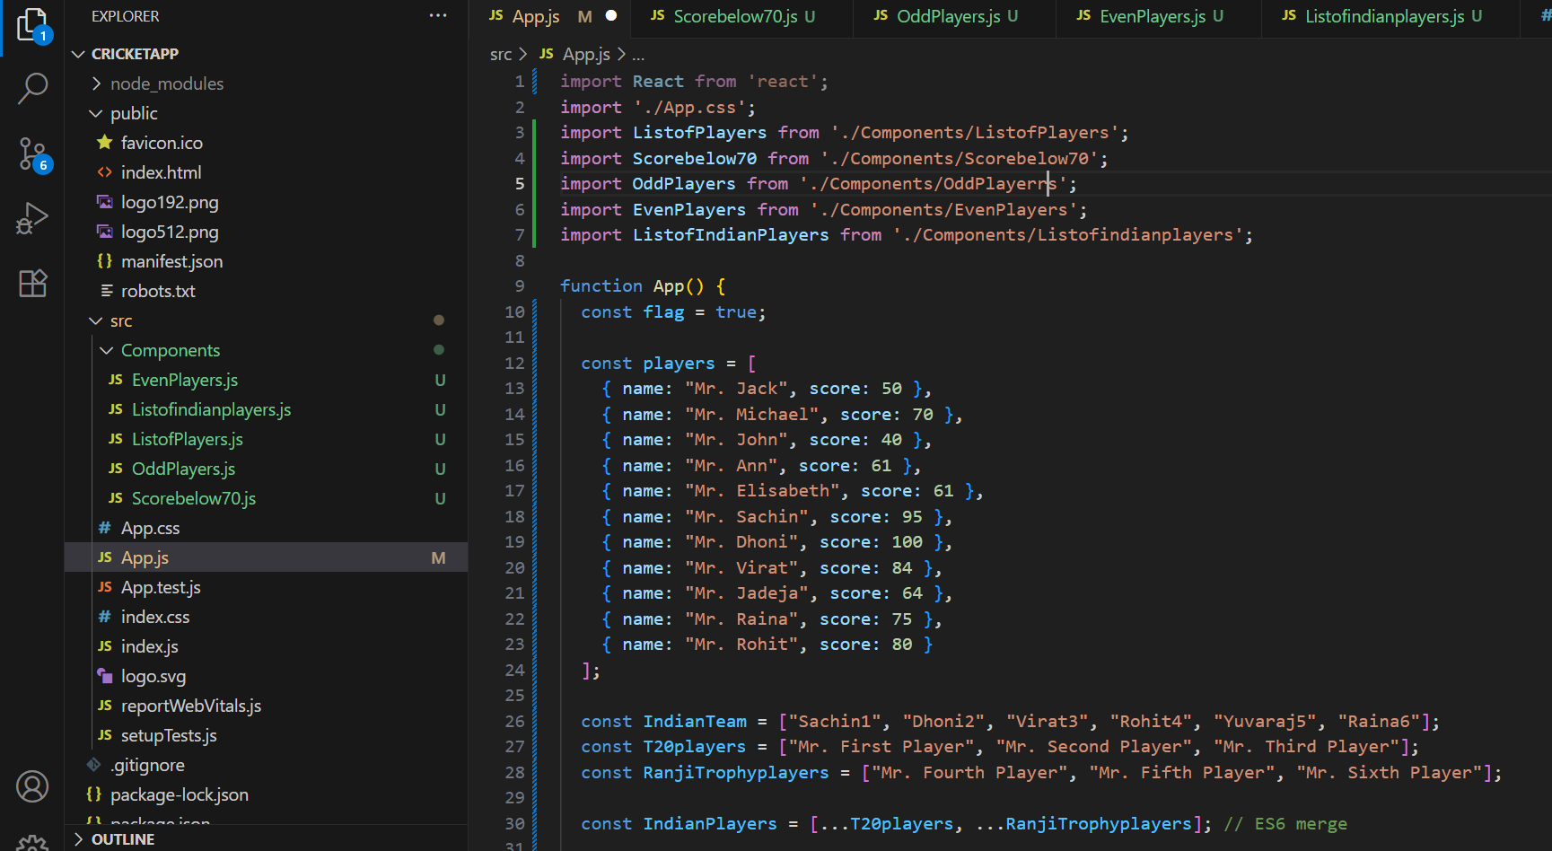

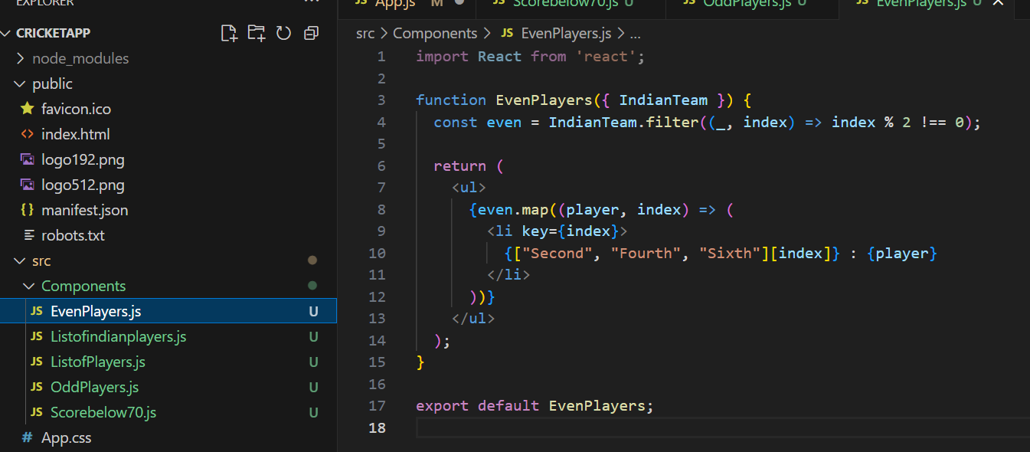

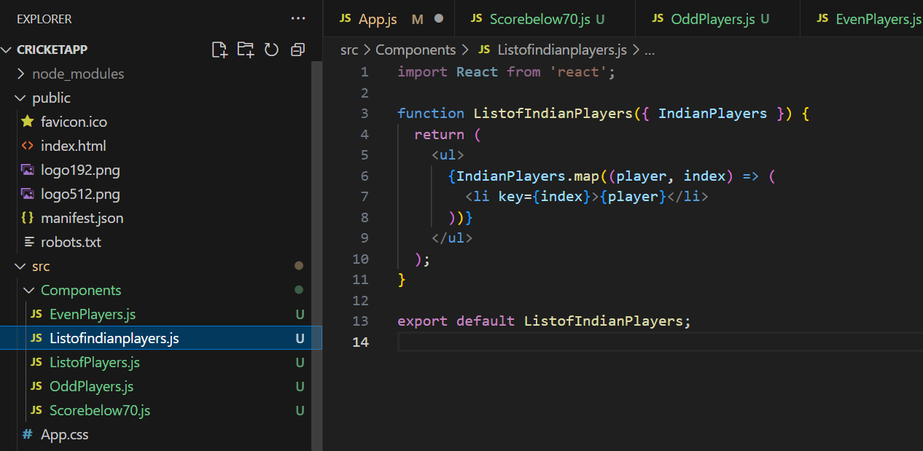

**Problem no:2**

Create a React Application named “officespacerentalapp” which uses React JSX to create elements, attributes and renders DOM to display the page.

Create an element to display the heading of the page.

Attribute to display the image of the office space

Create an object of office to display the details like Name, Rent and Address.

Create a list of Object and loop through the office space item to display more data.

To apply Css, Display the color of the Rent in Red if it’s below 60000 and in Green if it’s above 60000.

Output:

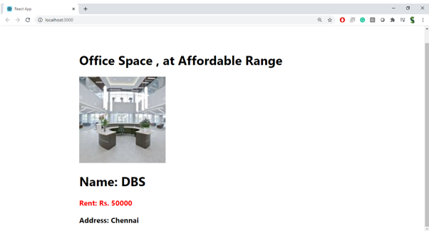

**Hint:**

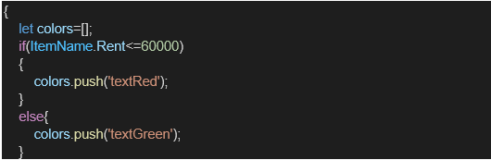

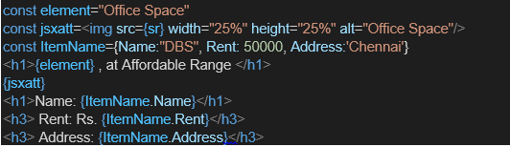

**Solution:**

**App.js**

import React from 'react';

import './App.css';

function App() {

  const officeList = [

    {

      name: "IndiQube",

      rent: 50000,

      address: "MG Road, Bangalore",

      image: "https://up.yimg.com/ib/th/id/OIP.Ty-YtOV-WUfhwppnCNwc0gHaEK?pid=Api&rs=1&c=1&qlt=95&w=205&h=115"

    },

    {

      name: "WeWork",

      rent: 75000,

      address: "Koramangala, Bangalore",

      image: "https://tse2.mm.bing.net/th/id/OIP.9oCqRdTmAk_d2W6ikIdnjwHaE8?pid=Api&P=0&h=180"

    },

    {

      name: "91SpringBoard",

      rent: 60000,

      address: "HSR Layout, Bangalore",

      image: "https://tse3.mm.bing.net/th/id/OIP.hX09757p3GwSAWDo-U3wQwHaFj?pid=Api&P=0&h=180"

    }

  ];

  const getRentStyle = (rent) => {

    return {

      color: rent < 60000 ? 'red' : 'green',

      fontWeight: 'bold'

    };

  };

  return (

    <div className="App">

      <h1>🏢 Office Space Rental Portal</h1>

      {officeList.map((office, index) => (

        <div key={index} style={{ border: '1px solid gray', margin: '20px', padding: '15px', borderRadius: '10px' }}>

          <img src={office.image} alt={`${office.name} Image`} width="300" height="150" />

          <h2>{office.name}</h2>

          <p>📍 Address: {office.address}</p>

          <p style={getRentStyle(office.rent)}>💸 Rent: ₹{office.rent}</p>

        </div>

      ))}

    </div>

  );

}

export default App;

**App.css**

.App {

  text-align: center;

  font-family: 'Segoe UI', Tahoma, Geneva, Verdana, sans-serif;

}

h1 {

  margin-top: 20px;

  color: #003366;

}

**Output Images:**

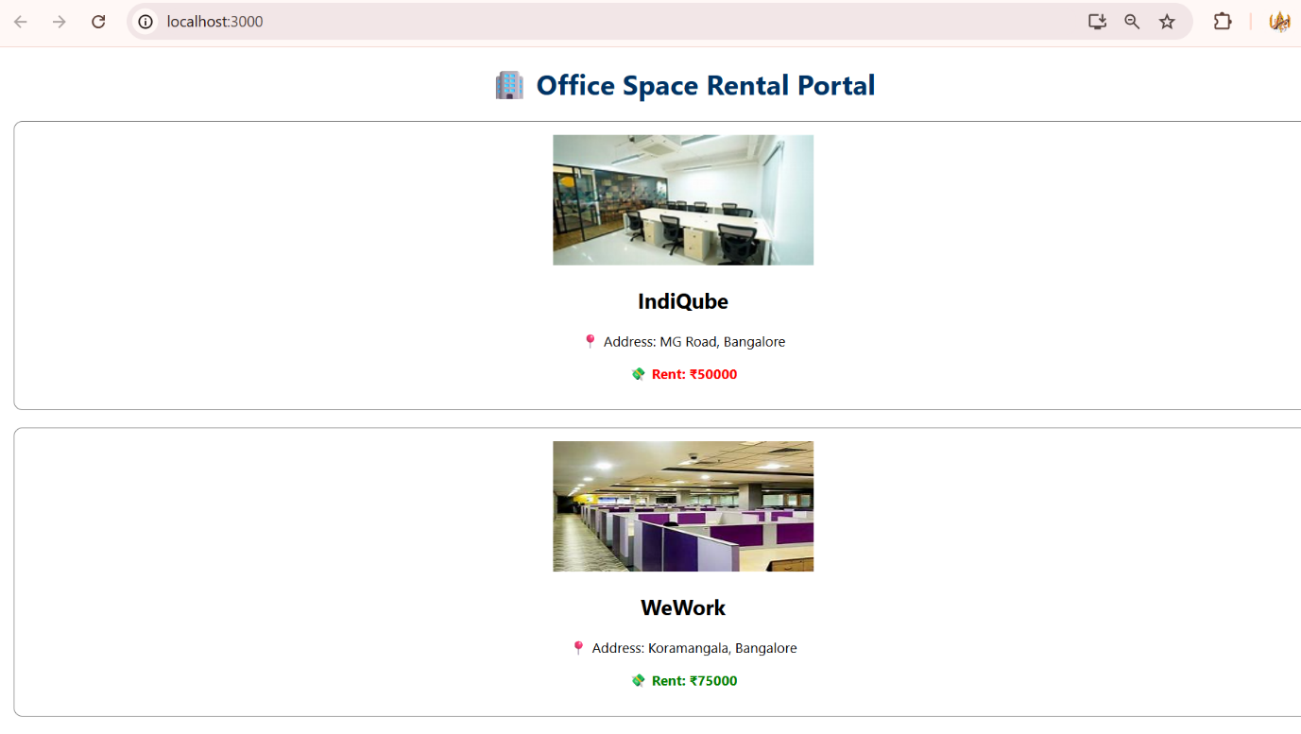

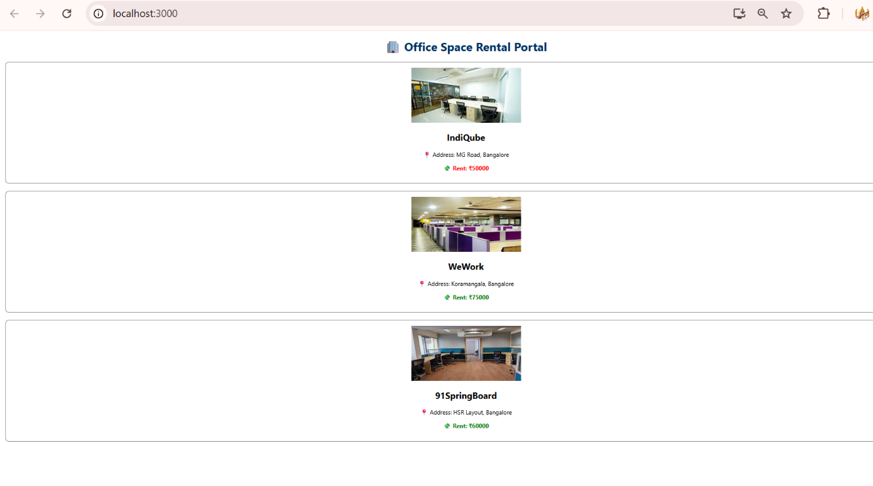

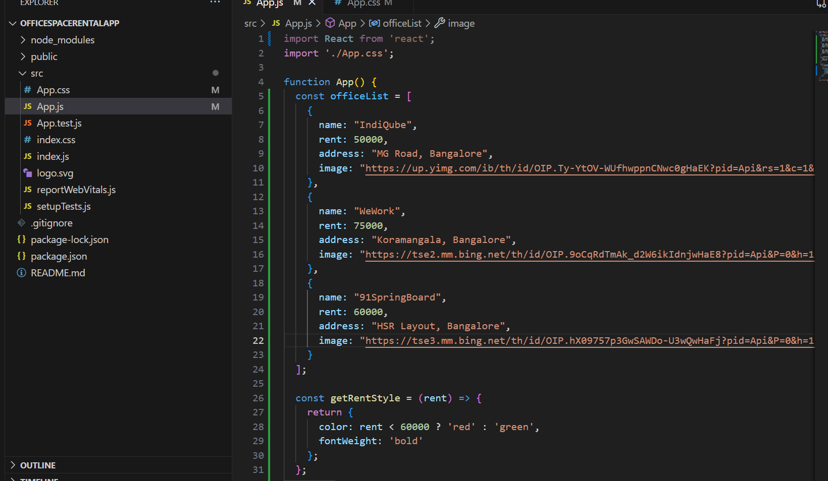

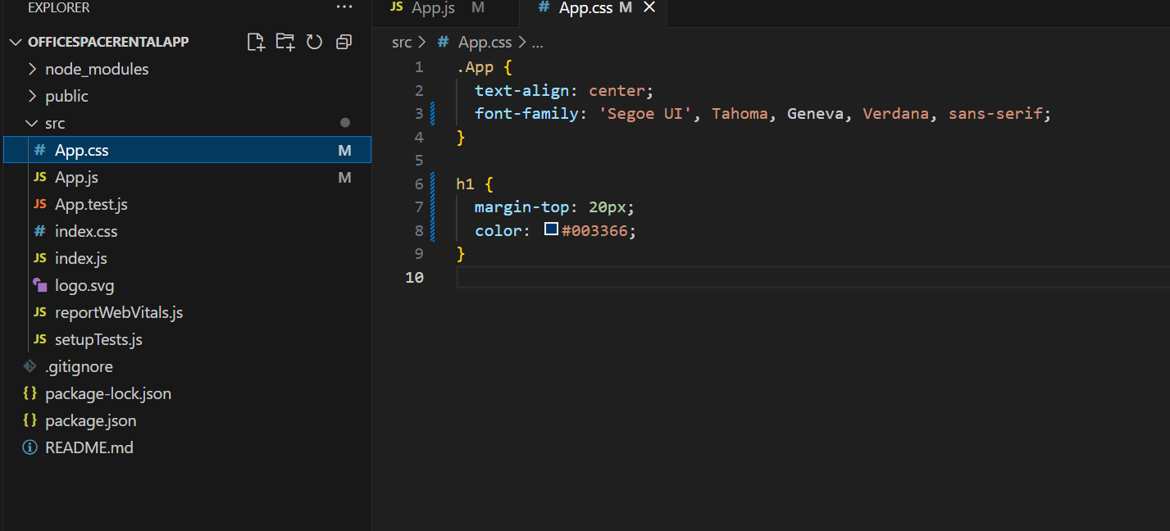

**Problem no:3**

Create a React Application “eventexamplesapp” to handle various events of the form elements in HTML.

1. Create “Increment” button to increase the value of the counter and “Decrement” button to decrease the value of the counter. The “Increase” button should invoke multiple methods.
   1. To increment the value
   2. Say Hello followed by a static message.

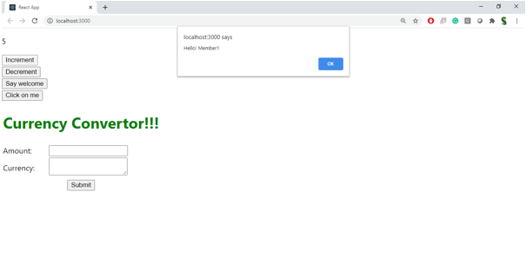

1. Create a button “Say Welcome” which invokes the function which takes “welcome” as an argument.

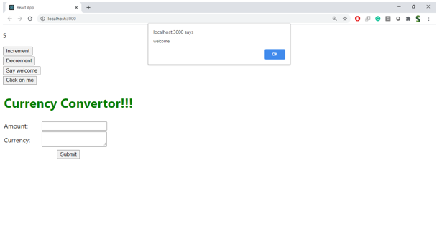

1. Create a button which invokes synthetic event “OnPress” which display “I was clicked”

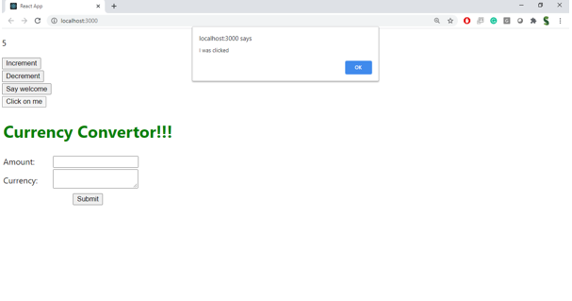

Create a “CurrencyConvertor” component which will convert the Indian Rupees to Euro when the Convert button is clicked.

Handle the Click event of the button to invoke the handleSubmit event and handle the conversion of the euro to rupees.

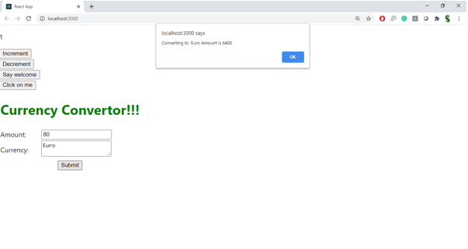

**Solution:**

**App.js**

import React, { useState } from "react";

import CurrencyConvertor from "./CurrencyConvertor";

import "./App.css";

function App() {

  const [count, setCount] = useState(0);

  const increment = () => {

    setCount(count + 1);

    sayHello();

  };

  const sayHello = () => {

    alert("Hello! You just clicked Increment.");

  };

  const decrement = () => {

    setCount(count - 1);

  };

  const sayWelcome = (message) => {

    alert(message);

  };

  const handleClick = (event) => {

    alert("I was clicked");

  };

  return (

    <div className="App">

      <h2>Counter: {count}</h2>

      <button onClick={increment}>Increment</button>

      <button onClick={decrement}>Decrement</button>

      <br /><br />

      <button onClick={() => sayWelcome("Welcome to React!")}>

        Say Welcome

      </button>

      <br /><br />

      <button onClick={handleClick}>Click on me</button>

      <br /><br />

      <CurrencyConvertor />

    </div>

  );

}

export default App;

**CurrencyConverter.js**

import React, { useState } from "react";

function CurrencyConvertor() {

  const [euro, setEuro] = useState("");

  const [rupees, setRupees] = useState("");

  const handleSubmit = () => {

    const result = (parseFloat(euro) * 90).toFixed(2); // 1 Euro = ₹90

    setRupees(result);

  };

  return (

    <div>

      <h2>💱 Currency Convertor (EUR → INR)</h2>

      <label>Enter Amount in Euro: </label>

      <input

        type="number"

        value={euro}

        onChange={(e) => setEuro(e.target.value)}

      />

      <button onClick={handleSubmit}>Convert</button>

      {rupees && (

        <p>

          ₹ Rupees Value: <strong>₹{rupees}</strong>

        </p>

      )}

    </div>

  );

}

export default CurrencyConvertor;

**App.css**

.App {

  text-align: center;

}

.App-logo {

  height: 40vmin;

  pointer-events: none;

}

@media (prefers-reduced-motion: no-preference) {

  .App-logo {

    animation: App-logo-spin infinite 20s linear;

  }

}

.App-header {

  background-color: #282c34;

  min-height: 100vh;

  display: flex;

  flex-direction: column;

  align-items: center;

  justify-content: center;

  font-size: calc(10px + 2vmin);

  color: white;

}

.App-link {

  color: #61dafb;

}

@keyframes App-logo-spin {

  from {

    transform: rotate(0deg);

  }

  to {

    transform: rotate(360deg);

  }

}

.App {

  font-family: Arial;

  text-align: center;

  margin-top: 20px;

}

button {

  margin: 10px;

  padding: 10px 15px;

  cursor: pointer;

  background-color: #007bff;

  border: none;

  color: white;

  border-radius: 5px;

}

button:hover {

  background-color: #0056b3;

}

**Output Images:**

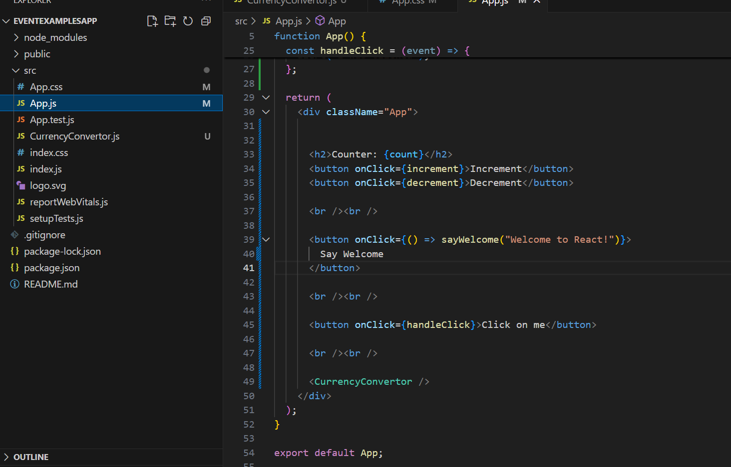

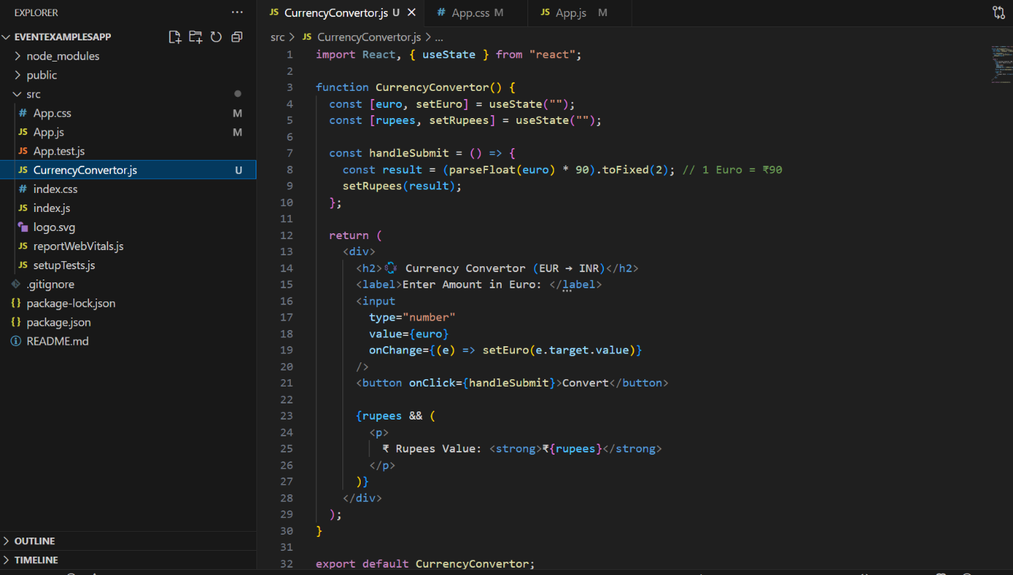

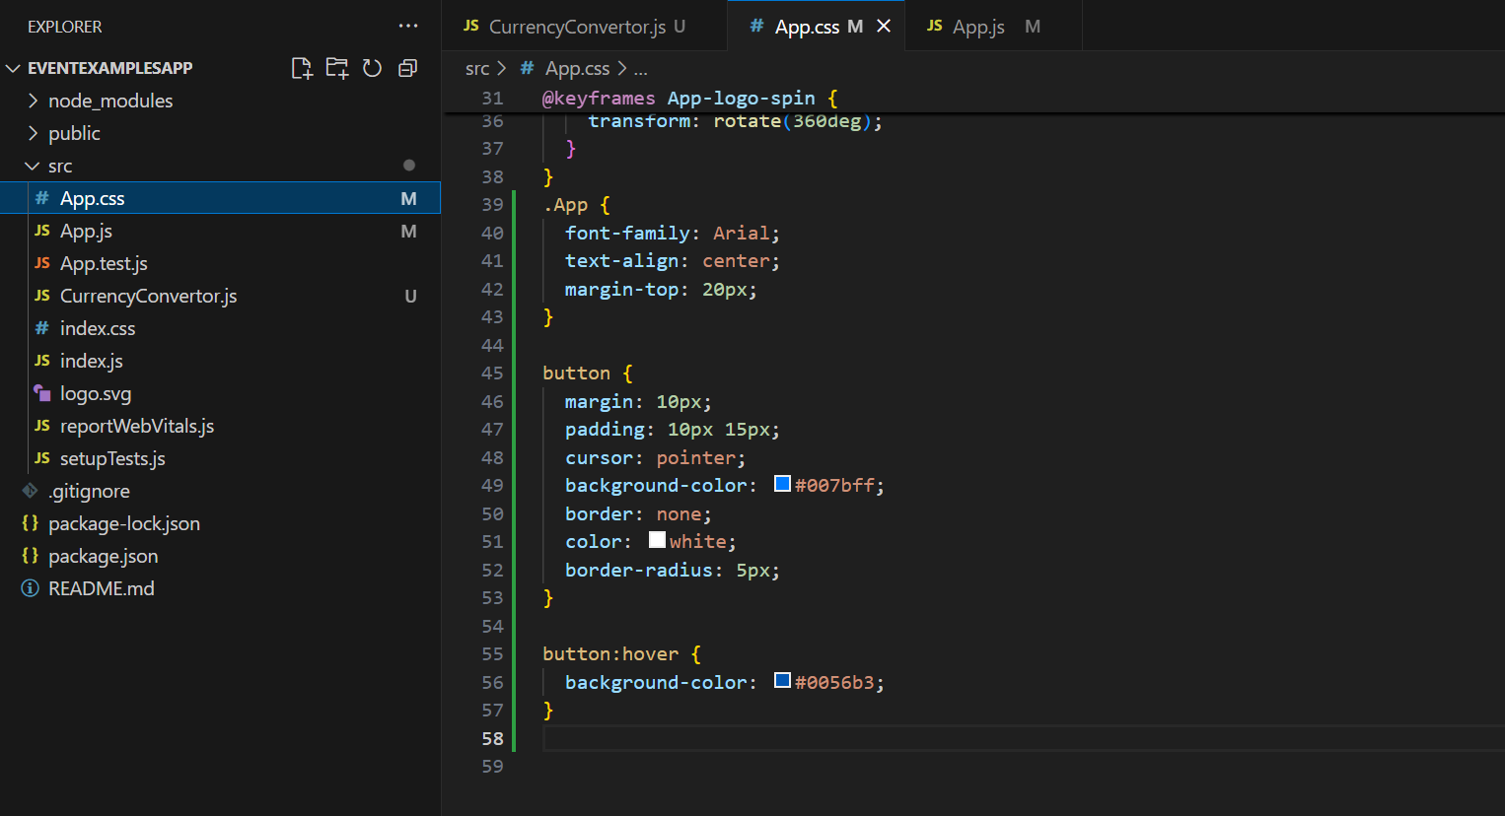

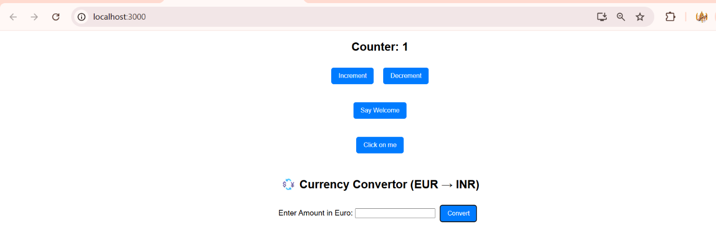

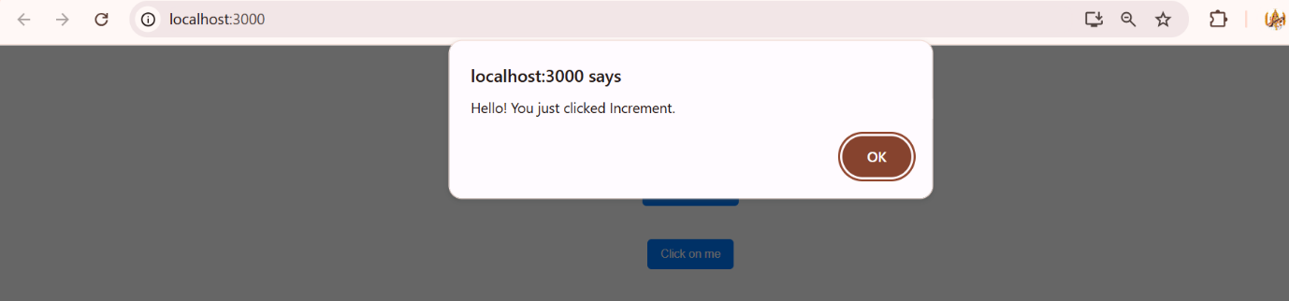

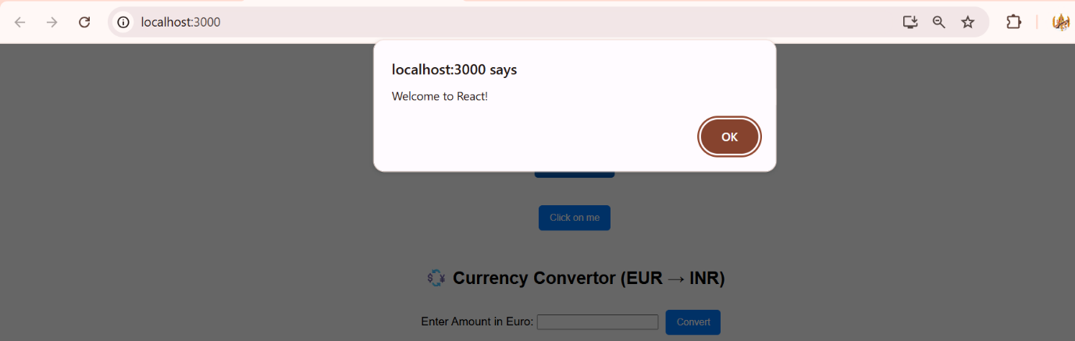

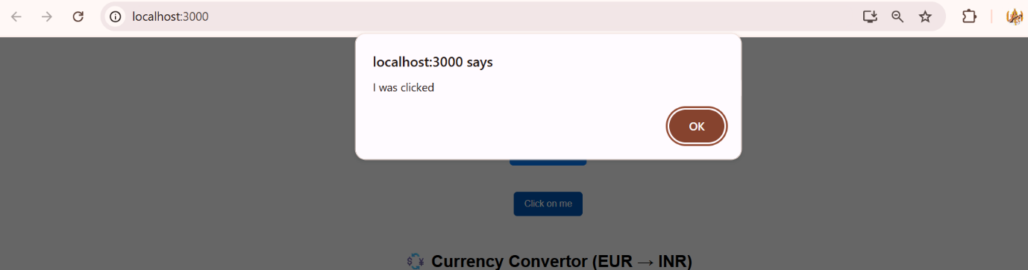

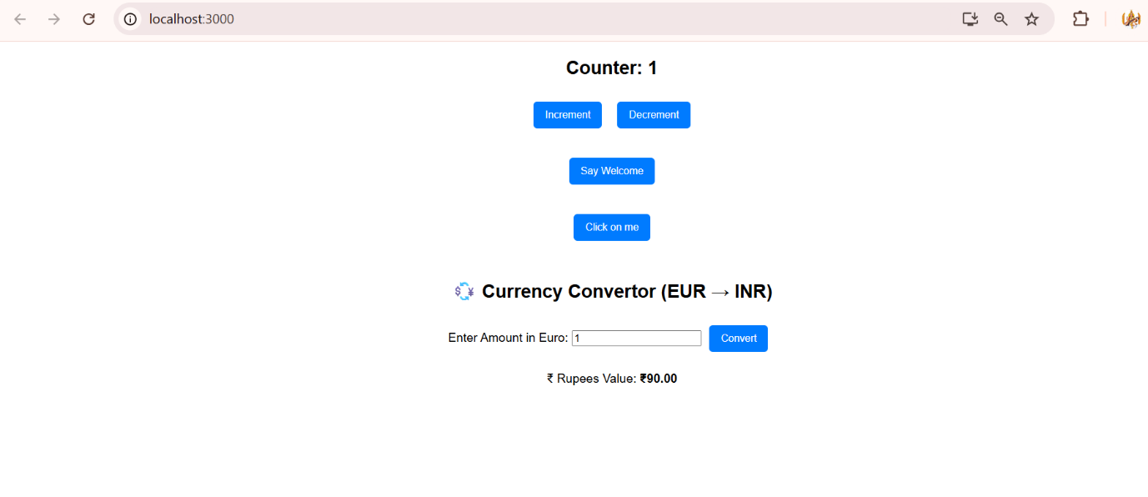

**Problem no:4**

Create a React Application named “ticketbookingapp” where the guest user can browse the page where the flight details are displayed whereas the logged in user only can book tickets.

The Login and Logout buttons should accordingly display different pages. Once the user is logged in the User page should be displayed. When the user clicks on Logout, the Guest page should be displayed.

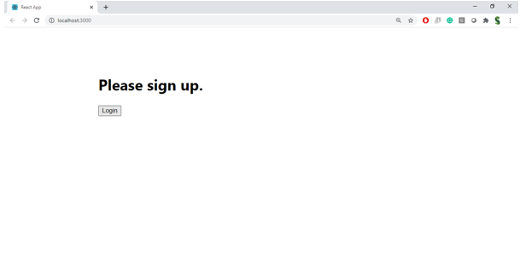

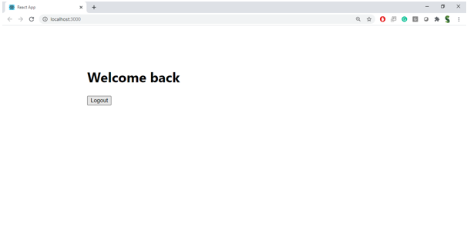

**Hint:**

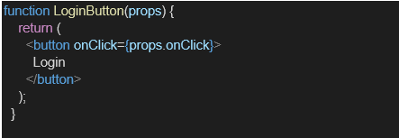

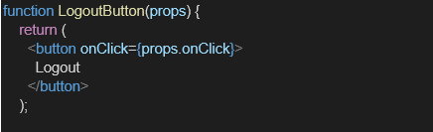

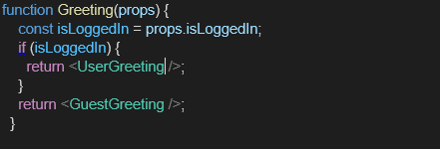

**Solution:**

**Greeting.js**

import UserGreeting from './UserGreeting';

import GuestGreeting from './GuestGreeting';

function Greeting(props) {

  const isLoggedIn = props.isLoggedIn;

  if (isLoggedIn) {

    return <UserGreeting />;

  }

  return <GuestGreeting />;

}

export default Greeting;

**GuestGreeting.js**

function GuestGreeting() {

  return <h1>Please sign up.</h1>;

}

export default GuestGreeting;

**LoginButton.js**

function LoginButton(props) {

  return (

    <button onClick={props.onClick}>

      Login

    </button>

  );

}

export default LoginButton;

**LogoutBuuton.js**

function LogoutButton(props) {

  return (

    <button onClick={props.onClick}>

      Logout

    </button>

  );

}

export default LogoutButton;

**UserGreeting.js**

function UserGreeting() {

  return <h1>Welcome back</h1>;

}

export default UserGreeting;

**App.js**

import React, { useState } from 'react';

import Greeting from './Components/Greeting';

import LoginButton from './Components/LoginButton';

import LogoutButton from './Components/LogoutButton';

import './App.css';

function App() {

  const [isLoggedIn, setIsLoggedIn] = useState(false);

  const handleLoginClick = () => {

    setIsLoggedIn(true);

  };

  const handleLogoutClick = () => {

    setIsLoggedIn(false);

  };

  let button;

  if (isLoggedIn) {

    button = <LogoutButton onClick={handleLogoutClick} />;

  } else {

    button = <LoginButton onClick={handleLoginClick} />;

  }

  return (

    <div style={{ textAlign: 'center', marginTop: '100px' }}>

      <Greeting isLoggedIn={isLoggedIn} />

      {button}

    </div>

  );

}

export default App;

**Output Images:**

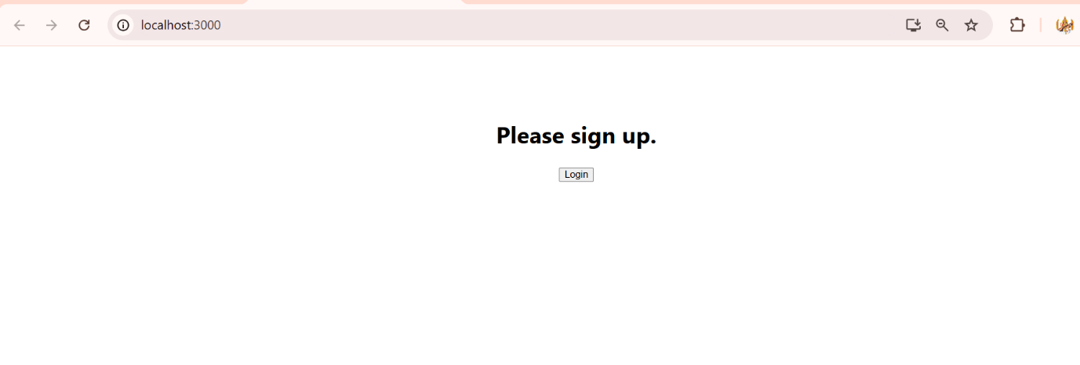

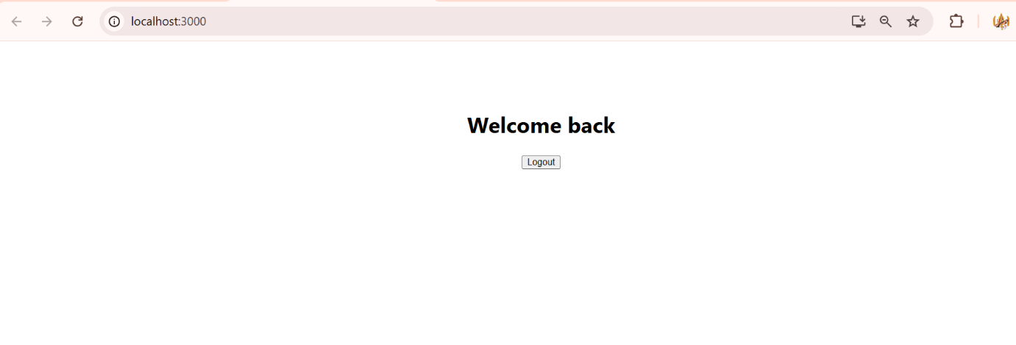

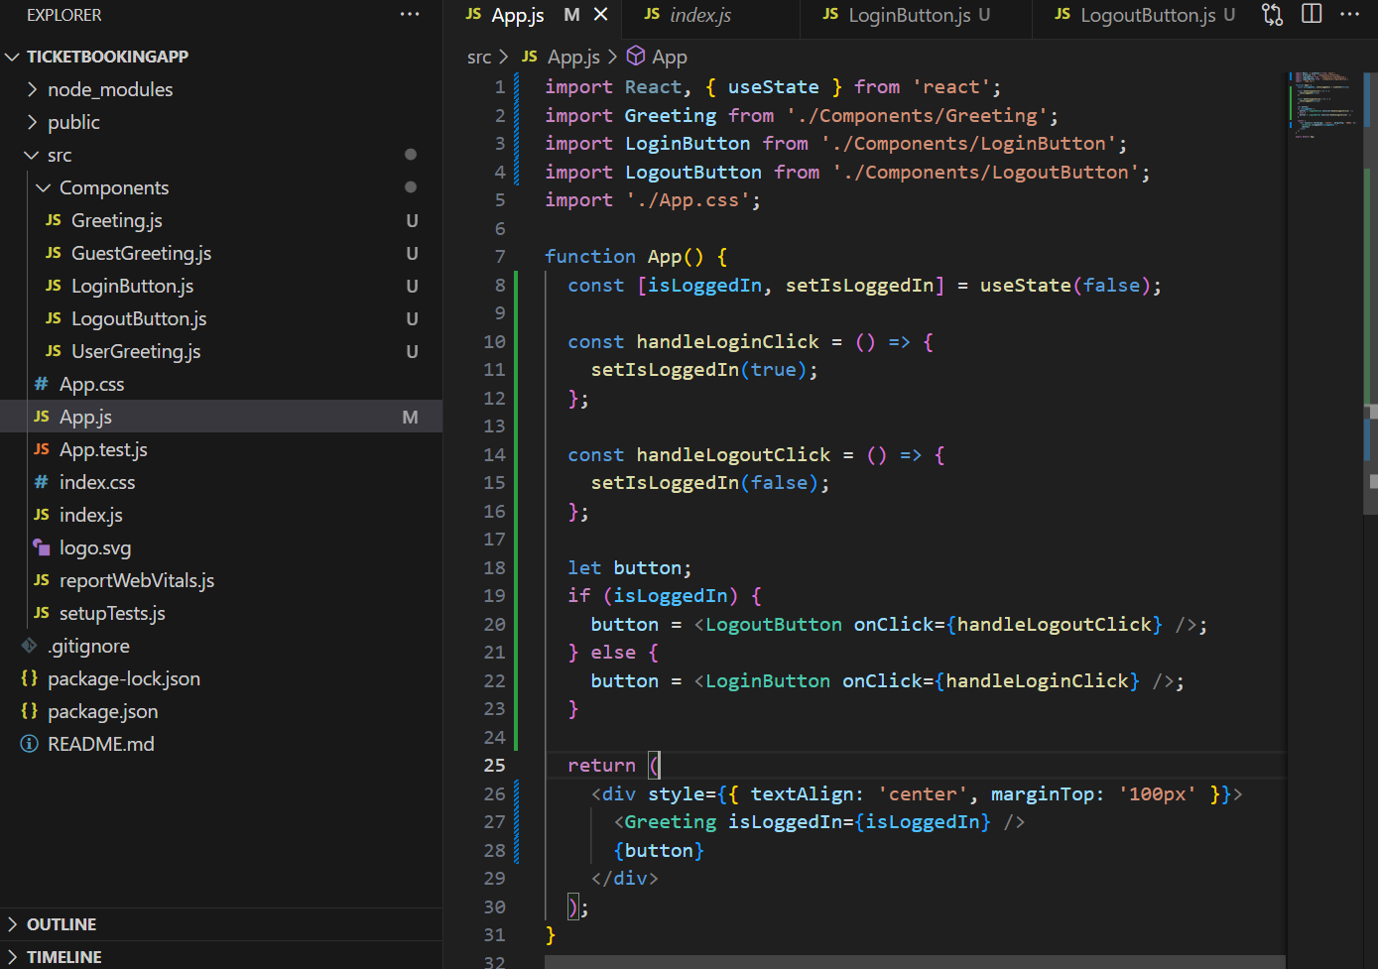

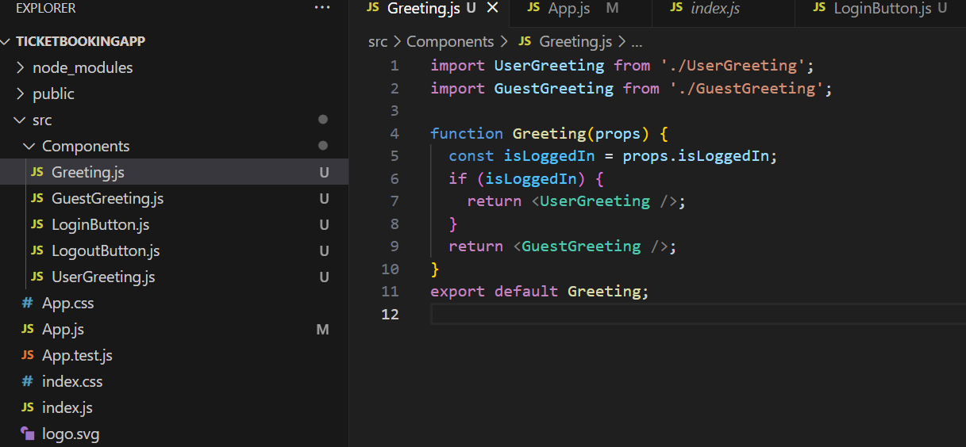

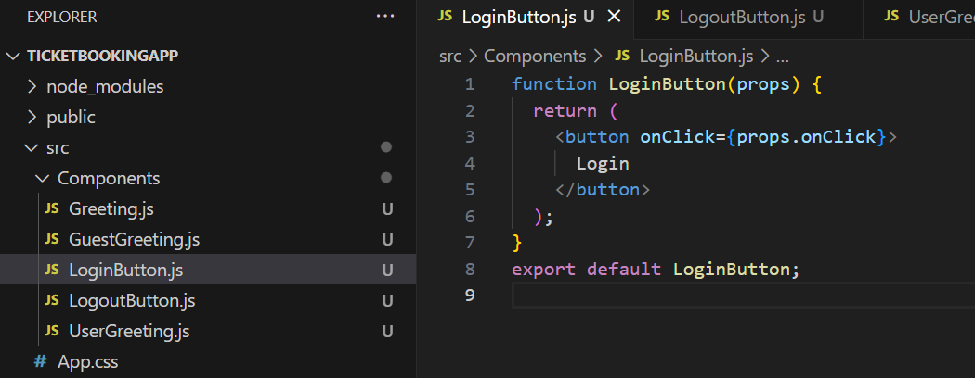

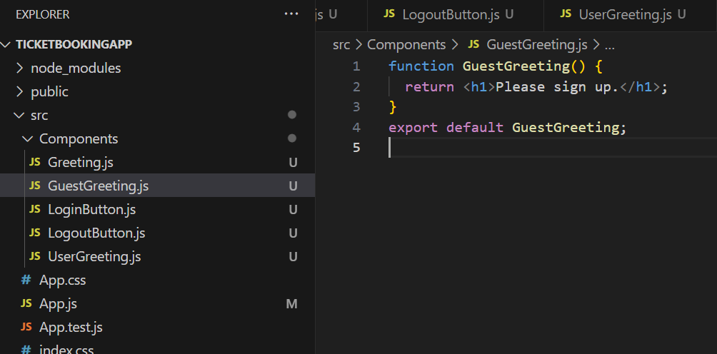

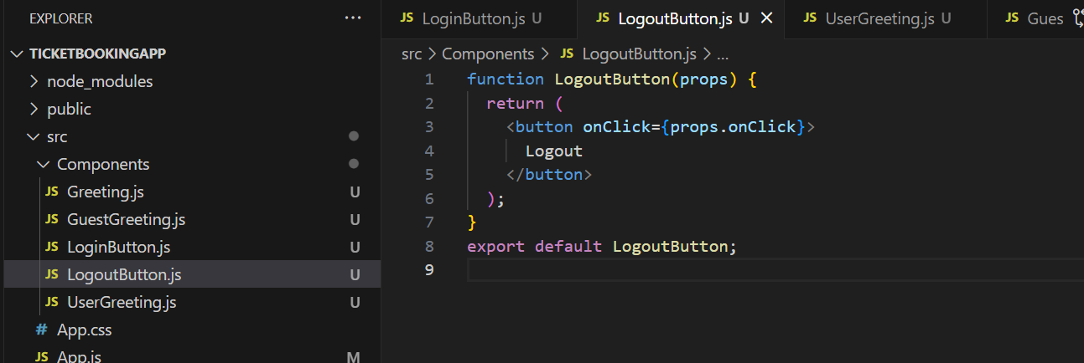

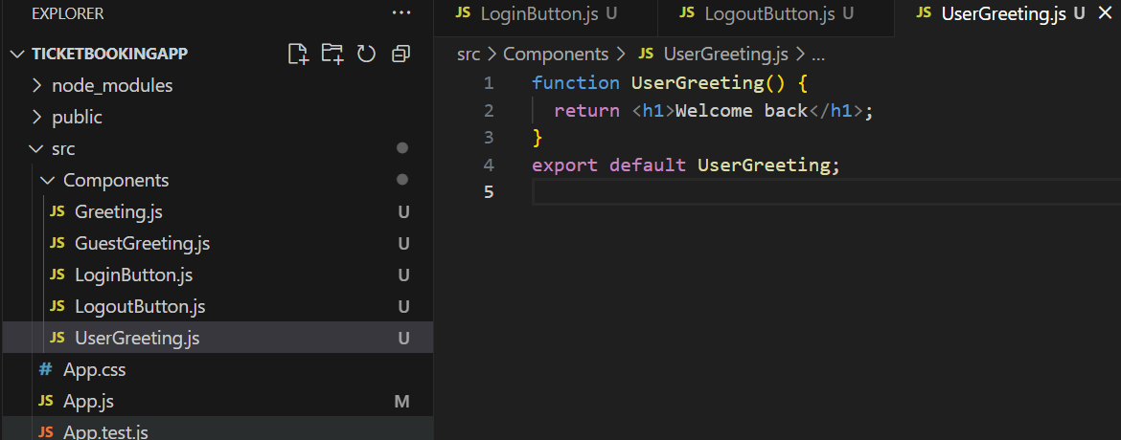

**Problem no:5**

Create a React App named “bloggerapp” in with 3 components.

1. Book Details
2. Blog Details
3. Course Details

Implement this with as many ways possible of Conditional Rendering.

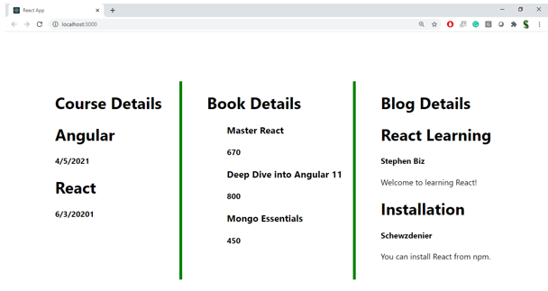

**Hint:**

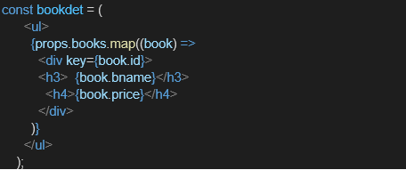

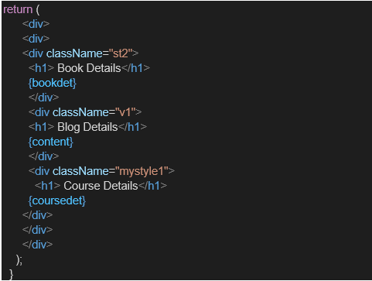

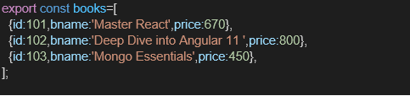

**Solution:**

**BlogDetails.js**

import React from 'react';

const BlogDetails = ({ show }) => {

  return show ? (

    <div className="v1">

      <h1>Blog Details</h1>

      <h2>React Learning</h2>

      <h4>Stephen Biz</h4>

      <p>Welcome to learning React!</p>

      <h2>Installation</h2>

      <h4>Schwezdenier</h4>

      <p>You can install React from npm.</p>

    </div>

  ) : null;

};

export default BlogDetails;

**BookDetails.js**

import React from 'react';

const BookDetails = (props) => {

  const bookdet = (

    <ul>

      {props.books.map((book) => (

        <div key={book.id}>

          <h3>{book.bname}</h3>

          <h4>{book.price}</h4>

        </div>

      ))}

    </ul>

  );

  return (

    <div className="st2">

      <h1>Book Details</h1>

      {bookdet}

    </div>

  );

};

export default BookDetails;

**CourseDetails.js**

import React from 'react';

const CourseDetails = ({ show }) => {

  if (!show) return null;

  const coursedet = (

    <ul>

      <div>

        <h3>Angular</h3>

        <h4>4/5/2021</h4>

      </div>

      <div>

        <h3>React</h3>

        <h4>6/3/20201</h4>

      </div>

    </ul>

  );

  return (

    <div className="mystyle1">

      <h1>Course Details</h1>

      {coursedet}

    </div>

  );

};

export default CourseDetails;

**App.js**

import React, { useState } from 'react';

import './App.css';

import BookDetails from './components/BookDetails';

import BlogDetails from './components/BlogDetails';

import CourseDetails from './components/CourseDetails';

import {books } from './data/Books';

function App() {

  const [showBooks, setShowBooks] = useState(true);

  const [showCourses, setShowCourses] = useState(true);

  const [showBlogs, setShowBlogs] = useState(true);

  return (

    <div className="App">

      <div style={{ display: 'flex', justifyContent: 'space-around' }}>

        {showBooks && <BookDetails books={books} />}

        <BlogDetails show={showBlogs} />

        <CourseDetails show={showCourses} />

      </div>

    </div>

  );

}

export default App;

**Book.js**

export const books = [

  { id: 101, bname: 'Master React', price: 670 },

  { id: 102, bname: 'Deep Dive into Angular 11', price: 800 },

  { id: 103, bname: 'Mongo Essentials', price: 450 },

];

**App.css**

.App {

  text-align: center;

}

.App-logo {

  height: 40vmin;

  pointer-events: none;

}

@media (prefers-reduced-motion: no-preference) {

  .App-logo {

    animation: App-logo-spin infinite 20s linear;

  }

}

.App-header {

  background-color: #282c34;

  min-height: 100vh;

  display: flex;

  flex-direction: column;

  align-items: center;

  justify-content: center;

  font-size: calc(10px + 2vmin);

  color: white;

}

.App-link {

  color: #61dafb;

}

@keyframes App-logo-spin {

  from {

    transform: rotate(0deg);

  }

  to {

    transform: rotate(360deg);

  }

}

.App {

  font-family: Arial, sans-serif;

  margin-top: 30px;

}

.mystyle1 {

  font-weight: bold;

  border-left: 4px solid green;

  padding-left: 20px;

}

.st2 {

  font-weight: bold;

  border-right: 4px solid green;

  padding-right: 20px;

}

.v1 {

  font-weight: bold;

  border-left: 4px solid green;

  border-right: 4px solid green;

  padding: 0 20px;

}

**Output Images**

